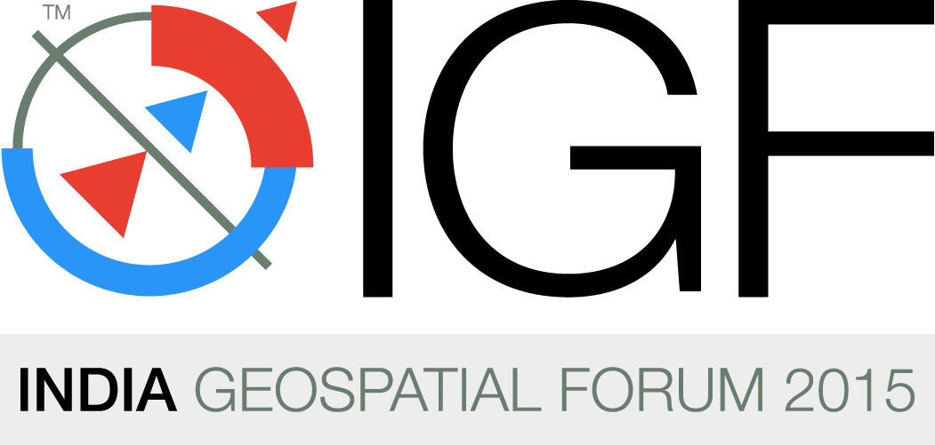

10th – 12th February 2015
HICC, Hyderabad, Andhra Pradesh

Additional Audiovisual Order Form | Please Return this Form to:-  Mr. Dharampal Singh Malhotra  Namdhari Events N Promotions (P) Ltd  +91 9885 27 28 29  dharam@namdharievents.com
Please fill the following Information Last date: 10th January 2015

Company Name:

Company Address:

City/Stage:

Country:

Zip Code/Pin Code:

Contact Person:

Position:

Telephone:

Fax:

E-Mail:

Date:

Company Website:

Additional Furniture :
Code.No | Item | Rate | Qty | Amount | Specifications
 |  | ( INR )
NES 040 | Plasma 42" with Stand | 4000
NES 041 | LCD Projector 2500 Lms Screen 6' x 4' | 3000
NES 042 | Laptop | 2000

Note:
* The above rates exclude service taxes @ 12.36%.
* All Demand draft payment to be drawn A/c Payee M/s Namdhari Events N Promotions (P) Ltd.
* These rates are applicable only for confirmed orders whose payments are received by 10th January 2015. Late orders/onsite orders will be levied a surcharge of 15% on the above mentioned prices.
* All items quoted above are purely on rental basis & for the entire show period
* Cheque payments are not accepted on built up or move in Date.
* Minimum time to deliver any order onsite would be 3 Hours & All orders Subject to availability.
* We do accept credit cards for payment which would attract 3% service charge which is apart from service tax.

